**Chapter 3**

**METHODS OF RESEARCH AND SOURCES OF DATA**

This chapter discusses the methods of research used and how the developed system was designed accordingly to justify a transition from the current system to proposed system. Furthermore, considerations were taken into account by the researcher in deciding certain course of actions. This chapter also includes data gathering tools, analytical tools, locale as well as the methods used in developing the system.

**Research Design**

Descriptive research was the method used by the researcher to complete the study. Descriptive research can be either quantitative or qualitative. It involves gathering data that describe events and then organizes, tabulates, depicts, and describes the data collection (Glass & Hopkins, 1984). It often uses visual aids such as graphs and charts to aid the reader in understanding the data distribution. Because the human mind cannot extract the full import of a large mass of raw data, descriptive statistics are very important in reducing the data to manageable form. The proponent used descriptive method for the part of research and developed the software that satisfied the stated objectives based from the yielded results of the research. Since the study was concerned in Campus Information System performance outputs, the descriptive method was the most appropriate method used that helped in the development of the proposed system. This method also defines the overall view and environment that will be included in the proposed system.

**System Development methodology**

The researcher used the spiral model in developing the system since it is a combination of iterative development process model and sequential linear development model such as waterfall model with very high emphasis on risk analysis. It allows for incremental releases of the product, or incremental refinement through its every iteration around the spiral. Spiral model is suitable in developing the proposed system since the system needs a serious planning on the requirements needed. Thus the system holds permanent records of students it would be worst if the system develop in a manner that without any preferable planning.

**The Spiral Model design**

The Spiral model combines the features of the Waterfall and Prototyping Incremental models. Using the Spiral methodology projects are formally separated into phases like Waterfall; however, they are broken up into incremental releases of the product, or incremental refinement through each time around the spiral. See the figure below. The spiral model has four phases. A software project repeatedly passes through these phases in iterations called Spirals.

**1. Identification**

**4. Evaluation & Risk analysis**

**2. Design**

System Design

**3. Construct or Build**

Business Requirements

Unit Requirements

System Requirements

Build 2

Build 1

Module Design

Architecture Design

Proof of Concept

Customer Feedback

Schedule Monitoring

Management Risk

**Releasing**

**Figure 2.0**

**1. Identification**

This phase starts with gathering the business requirements in the baseline spiral. In the subsequent spirals as the product matures, identification of system requirements, subsystem requirements and unit requirements are all done in this phase. This also includes understanding the system requirements by continuous communication between the customer and the system analyst. At the end of the spiral the product is deployed in the identified market.

**2. Design**

Design phase starts with the conceptual design in the baseline spiral and involves architectural design, logical design of modules, physical product design and final design in the subsequent spirals.

**3. Construct or Build**

Construct phase refers to production of the actual software product at every spiral. In the baseline spiral when the product is just thought of and the design is being developed a POC (Proof of Concept) is developed in this phase to get customer feedback. Then in the subsequent spirals with higher clarity on requirements and design details a working model of the software called build is produced with a version number. These builds are sent to customer for feedback.

**4. Evaluation and Risk Analysis**

Risk Analysis includes identifying, estimating, and monitoring technical feasibility and management risks, such as schedule slippage and cost overrun. After testing the build, at the end of first iteration, the customer evaluates the software and provides feedback. Based on the customer evaluation, software development process enters into the next iteration and subsequently follows the linear approach to implement the feedback suggested by the customer. The process of iterations along the spiral continues throughout the life of the software.

**Research Locale**

The research was conducted at CHCC School, Inc. located at Brgy. Minane Concepcion, Tarlac. All colleges’ students, teachers and staffs from the school were the intended users of the proposed system.

**1. Subject of the Study**

In this study the respondents are the students from 1st level up to 4th level, teachers and staffs of administration office of CHCC School Inc. The respondents consisted of 222 students from 1st  year level up to 4th year level and 2 staffs of administration office of the school.

**2. Population**

The total population for the study is 875 composed of, 873 students and 2 staffs of the school. The researcher get 25 percent from the total population of each respondent for the sampling that will use in statistical treatment of the study. With these, data that will be gathered from the respondents are reliable and accurate enough for statistical treatment and analysis.

**Data Gathering Tools**

Clerical tools such as interview, questionnaire and empirical observation methods were the ways in collecting data. Such gathering tools reveal unsatisfactory conditions that need improvement or applications of these facts and principles to remedy such conditions that became the basis for the development of the software by the researcher.

Data gathered were ensured first to be valid, reliable and suitable for the research topic. It contained items that are equivocal that led to the clear and definite directions for the completion of the study.

**1. Interview**

Interview is one of the techniques in data gathering through a purposeful face to face relationship between two persons who gathers (interviewer) and supplies (interviewee) information. In order to yield a more complete and valid information, the researcher used the interview method. Basically, this method is the initial data gathering technique that provides data directly from the source which makes it a reliable technique of gathering data.

The researcher wanted to gather significant and reliable information regarding the existing method used by the CHCC School, Inc. in terms of its performance. The researcher conducted interview on students, teachers, and staff who were responsible in handling the schools activity.

**2. Observation**

It is the most direct way and most widely used in studying behavior. It is a means of gathering information by perceiving data through the senses. It enabled the researchers to gather empirical data and sufficient enough to supplement and verify information. This method was used to collect directly primary or first-hand information which makes the study more accurate in description and interpretation.

The researcher went to the school to observe the method, environment and materials used in recording and reporting student grades and how the enrollment in school does being processed. The researchers had seen the processes undergone and methods used in computing performance-based grades of students and how the adviser consolidates all the grades from different subject teachers for periodical ranking of class and other school activity.

**3. Questionnaire or Evaluation Forms**

A questionnaire or evaluation form is a list of planned, written questions related to a particular topic, with space provided for indicating the response to each question, intended for submission to a number of persons for reply. The use of questionnaires made it easier for the researchers to tabulate gathered data and respondents replied and gave information freely with enough time to think reflectively or consult their records if necessary on their replies that made more accurate results.

The researcher prepared questionnaires which were showed for correction and suggestions for improvement to persons with adequate knowledge in questionnaires. After careful planning and editing of the questionnaires, the researcher administered the evaluation of the system through the questionnaires handed to the subjects of the study.

**Campus Information System**

**EVALUATION FORM**

**Name: _______________________________ Date: __________**

All of the information collected will be regarded as strictly confidential. Below are the criteria for evaluating the system. Please check the appropriate rating for each criterion.

**Direction**: Please check (🗸) the box for your preferred answer if it corresponds the statement of each item.

|  |  |  |  |  |
| --- | --- | --- | --- | --- |
| **Criteria** | | | **Existing System** | **Proposed System** |
| **1.** | **Security** | |  |  |
|  | a. | Requires user authentication. | 🗆 | 🗆 |
|  | b. | Provides backup and recovery of data. | 🗆 | 🗆 |
|  | c. | Controls data access of users. | 🗆 | 🗆 |
|  | d. | Sets user limits on access control keys. | 🗆 | 🗆 |
|  | e. | Protects system from foreign or external elements. | 🗆 | 🗆 |
| **2.** | **Efficiency** | |  |  |
|  | a. | Easy enrollment procedure | 🗆 | 🗆 |
|  | b. | Fast grades evaluation. | 🗆 | 🗆 |
|  | c. | Provided class schedules | 🗆 | 🗆 |
|  | d. | Accessibility of students’ grades. | 🗆 | 🗆 |
|  | e. | Quick balance assessment | 🗆 | 🗆 |
| **3.** | **Reliability** | |  |  |
|  | a. | Provides accurate grades | 🗆 | 🗆 |
|  | b. | Grades are always accessible | 🗆 | 🗆 |
|  | c. | Provides accurate balance assesment | 🗆 | 🗆 |
|  | d. | Provides adding and dropping of subject | 🗆 | 🗆 |
|  | e. | Provides accurate grades evalution. | 🗆 | 🗆 |

**Comments:** ___________________________________________________________

___________________________________________________________

**Signature:** ___________________

**4. Library and Internet Research**

Library is the most essential source of reliable information. It facilitates the process of gathering facts since the materials or resources in the library are arranged in standardized classification system which lessens or minimizes misleading information.

Internet is a powerful research aid since it has the ability to access the latest information. This tool is used to gather data by accessing and browsing sites and pages from individuals or entities around the world.

The researcher used these methods for further information gathering that may be helpful to the study. Concepcion Holy Cross College Library was the researcher reliable source for references that were relevant to the research study.

**Data Gathering Procedure**

The researcher used a survey questionnaire to gather the data needed. Upon presentation of the developed system the researcher administered the survey that allows the respondents to evaluate the system according to the criteria indicated in the survey form.

**Statistical Treatment**

Statistical treatments helped the researchers determine the validity and reliability of the research tools. It organized data systematically by ordered arrangement, ranking, score and frequencies. These treatments gave meaning and interpretation to data that are the basis for making conclusions. In this study, weighted mean, Likert scale, *t-test* and Rubrics method were used as statistical treatment.

Frequency distribution was used to describe the number of occurrence in each category. It shows the number of occurrences falling into each of several ranges of values. It shows either the actual number of observations falling in each range or the percentage of observations.

The formula for the weighted mean and average weighted mean:

Where:

n = refers to the total number of respondents

f = refers to the number of times that a given number was chosen by a respondent as a rating for a given criterion

X = represents any one numerical rating for a given criterion

**Formula for Variance (**)

Where:

= Variance

= Weighted Mean

= total sample size

**Formula for t-test**

Where:

= t-test computed value

= Weighted mean of the Existing System

= Weighted mean of the Proposed System

= Variance of the Existing System

= Variance of the Proposed System

= Sample Size

**Table 1.0 Interpretation Table**

|  |  |  |
| --- | --- | --- |
|  | **Likert Scale** | **Verbal Interpretation** |
| 1 | 0.000 – 1.499 | Poor |
| 2 | 1.500 – 2.499 | Fair |
| 3 | 2.500 – 3.499 | Satisfactory |
| 4 | 3.500 – 4.499 | Very Satisfactory |
| 5 | 4.500 – 5.000 | Excellent |

The researcher used the Likert scale to determine the performance of the developed system. The mean was computed and was weighed by determining at which scale it falls. Each scale has its corresponding description to conclude the evaluation of the system.

The researchers used the Rubrics method for the performance evaluation of the developed system based on the stated objectives that leads to the final product. The group used specific criteria as basis for evaluating the system performance as indicated in narrative descriptions that are separated into two levels of possible performance related to the given objectives: Security, Efficiency and Reliability. The scoring points for the Rubric Method will be 1 point for the each response on the sub criteria with a total of five (5) points per criteria

|  |  |  |  |  |
| --- | --- | --- | --- | --- |
| **Table 2.0** | | **Rubrics designed for evaluation of the criteria for Frequency Distribution** | | |
| **Criteria** | | | **Existing System** | **Proposed System** |
| **1.** | **Security** | |  |  |
|  | (5) Description of the developed system in terms of Security | |  |  |
| **2.** | **Efficiency** | |  |  |
|  | (5) Description of the developed system in terms of Efficiency | |  |  |
| **3.** | **Reliability** | |  |  |
|  | (5) Description of the developed system in terms of Reliability | |  |  |

**Main Page Flowchart**

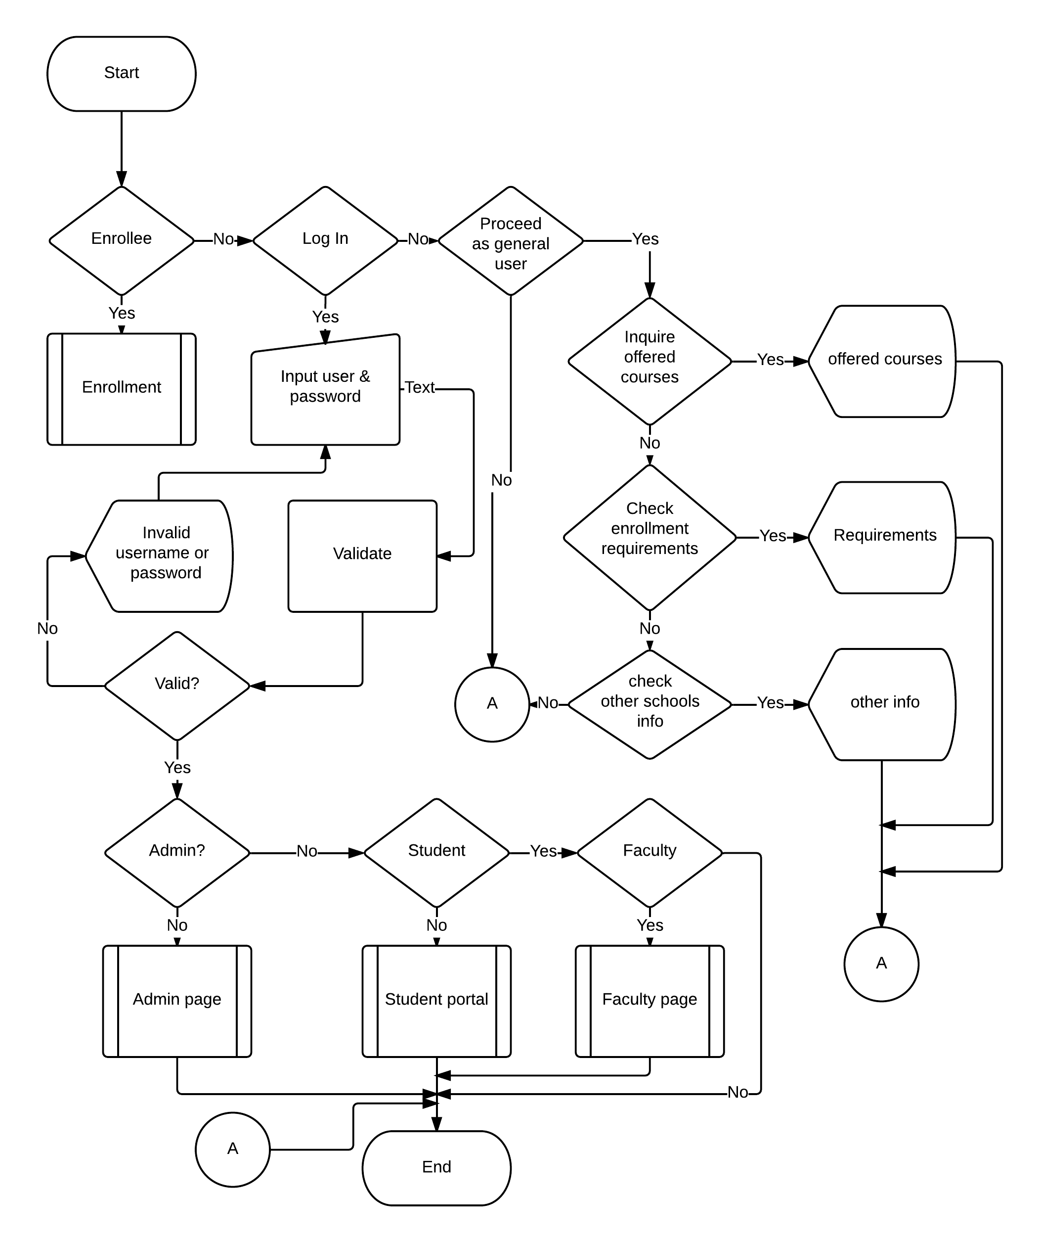

**Diagram no. 1**

**Admin Flowchart**

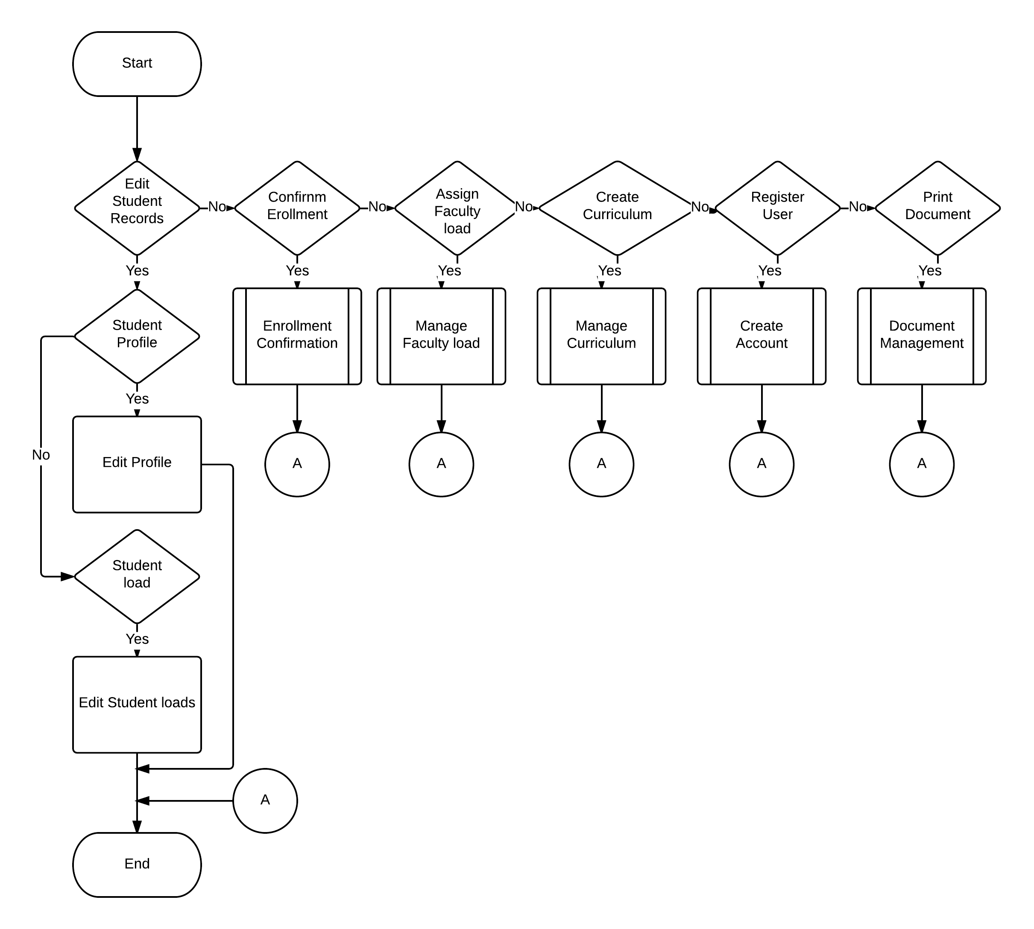

**Diagram no. 2**

**Faculty Page Flowchart**

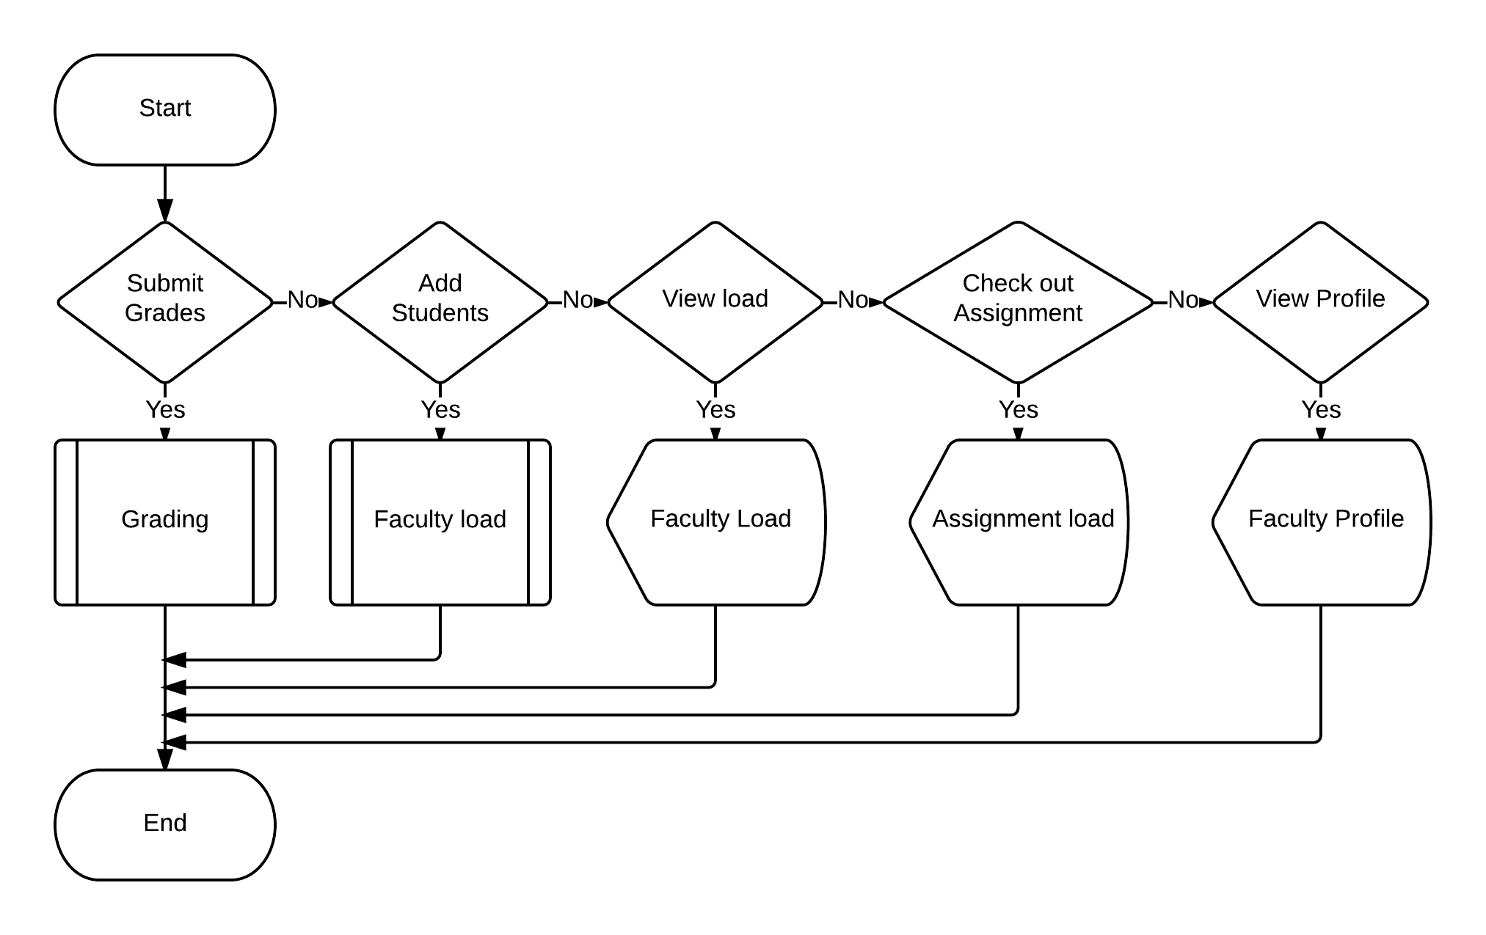

**Diagram no. 3**

**Student Page Flowchart**

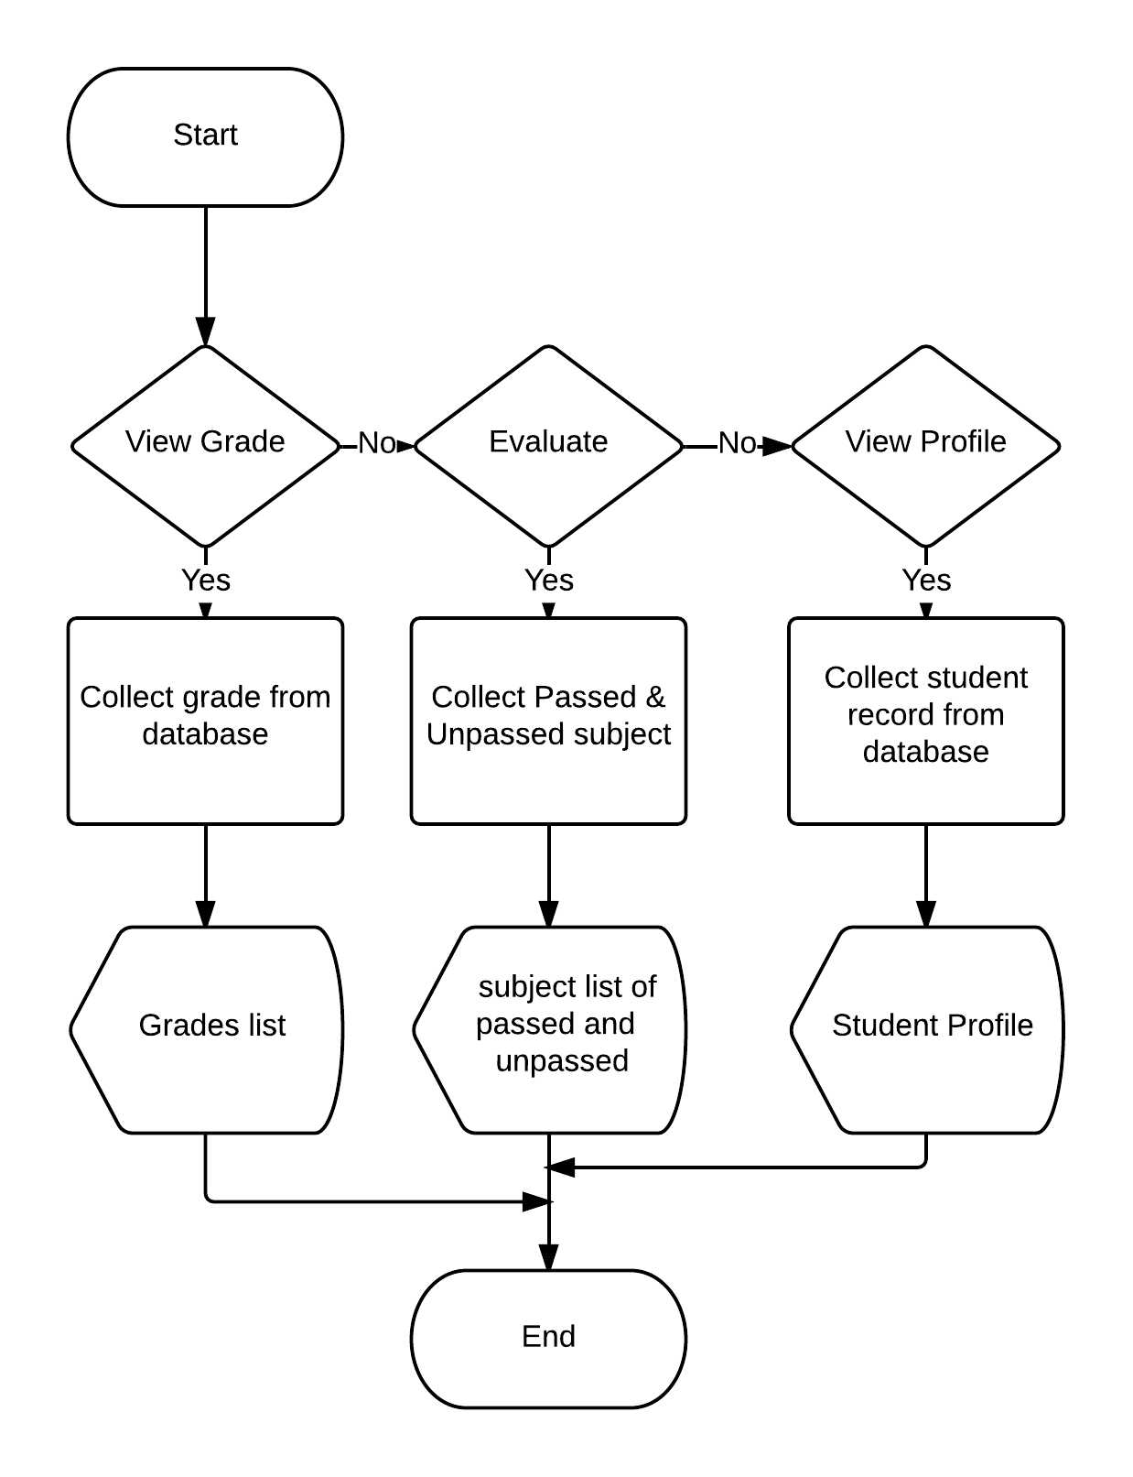

**Diagram no. 4**

**Enrollment flowchart**

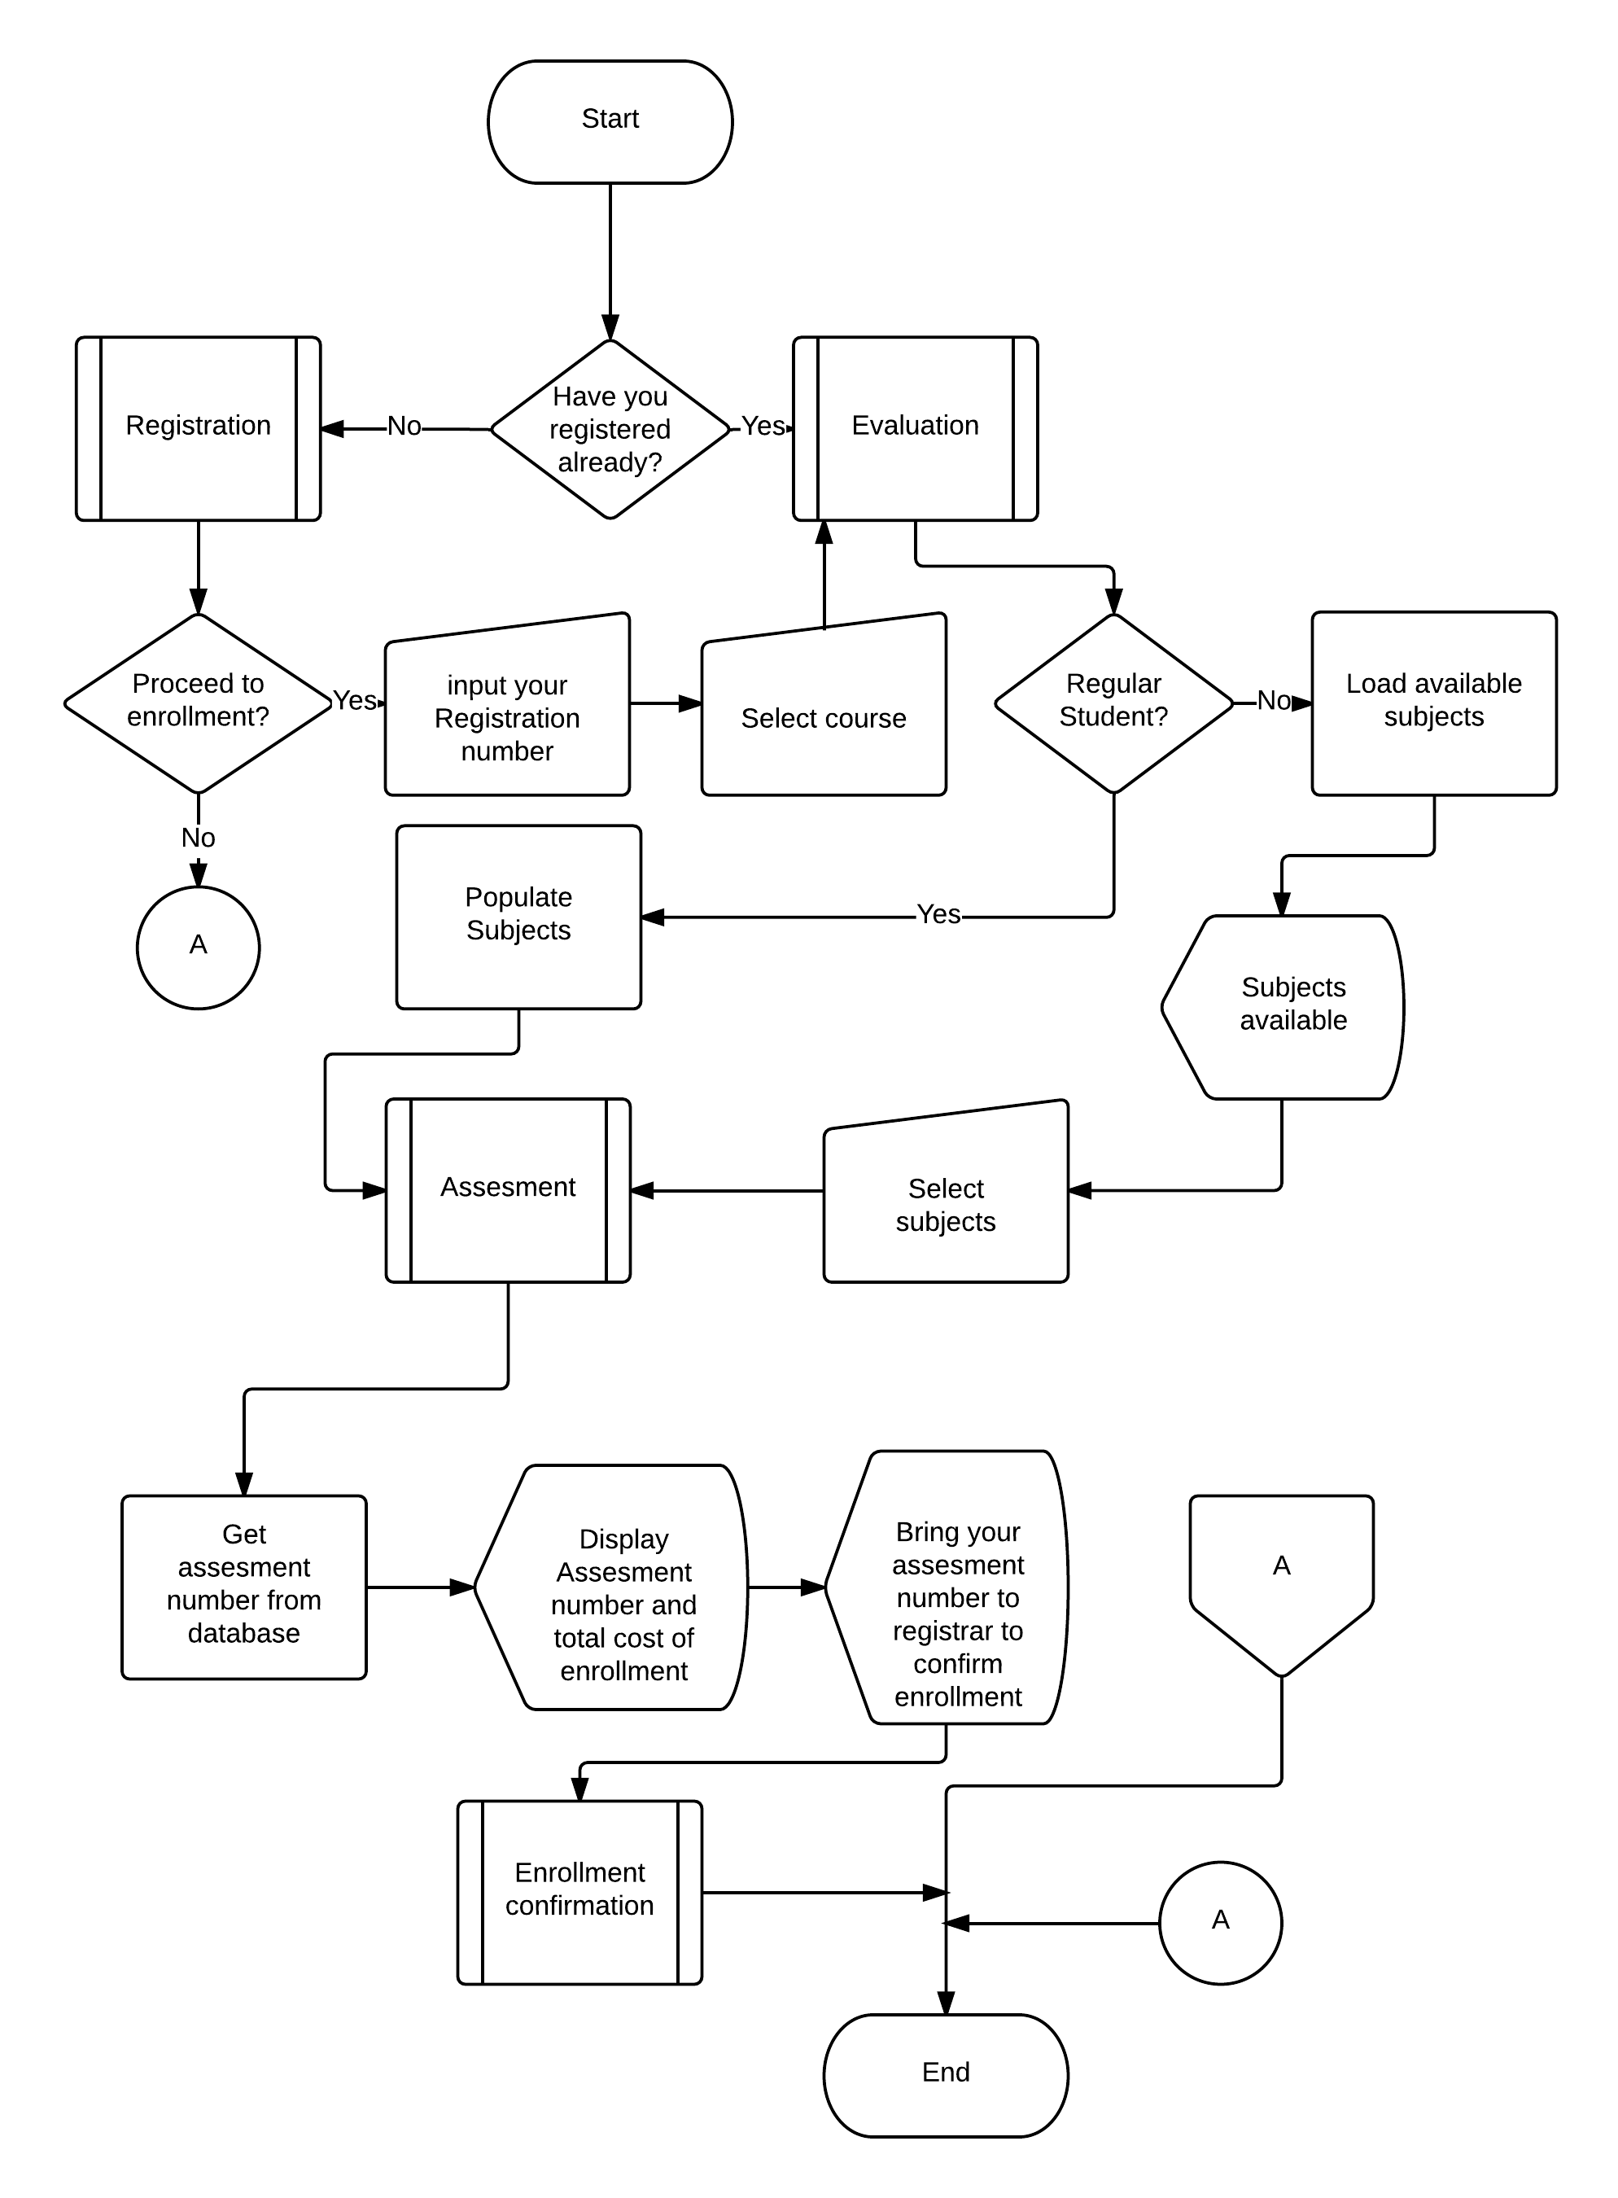

**Diagram no. 5**

**Registration Flowchart**

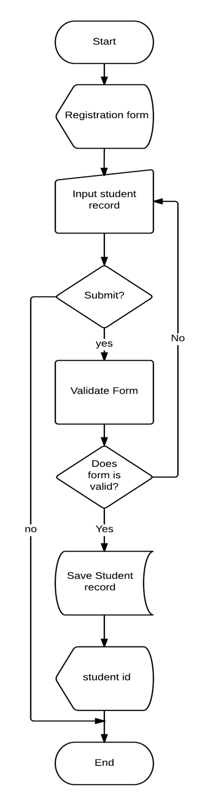

**Diagram no. 6**

**Evaluation flowchart**

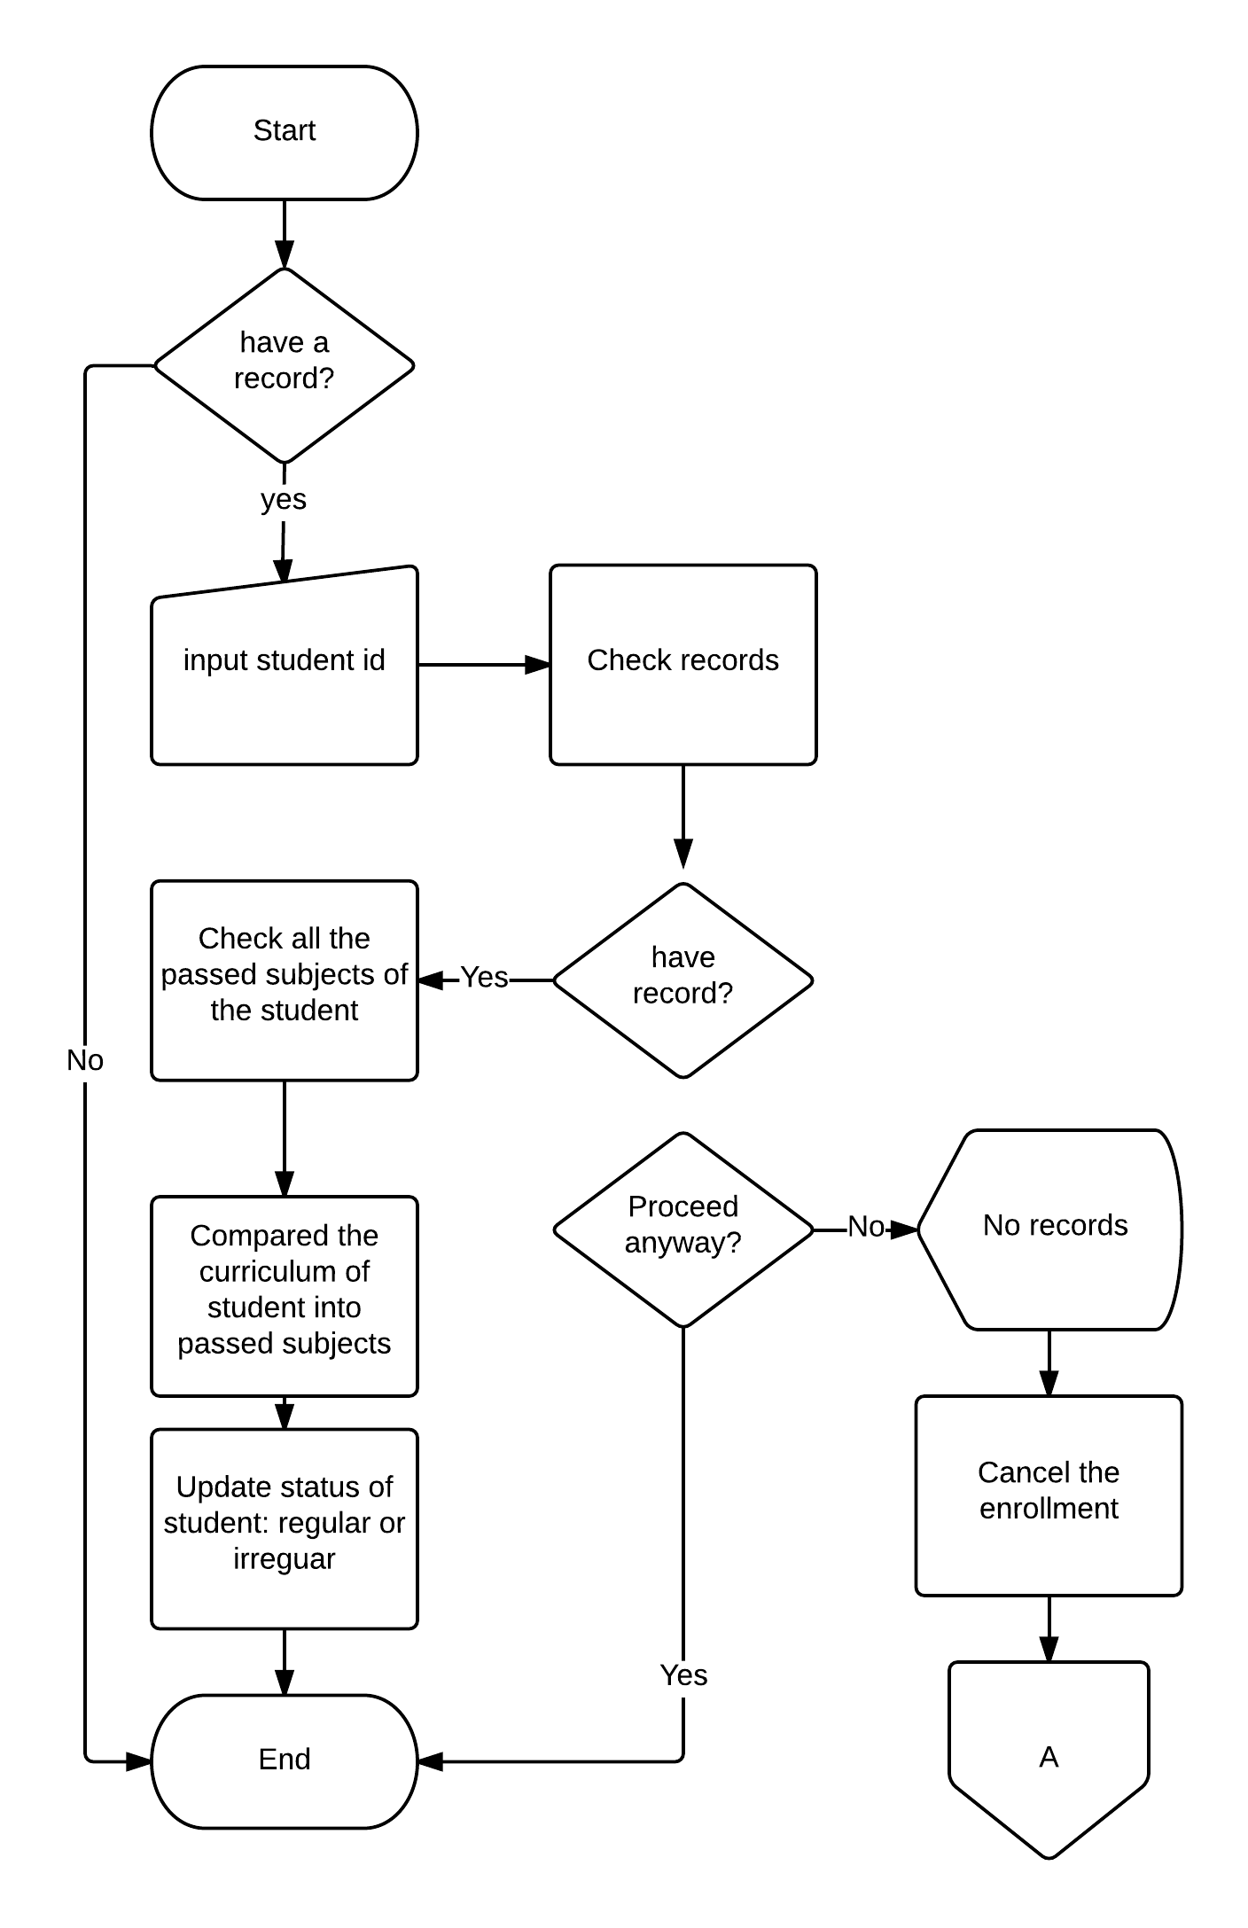

**Diagram no. 7**

**Assessment flowchart**

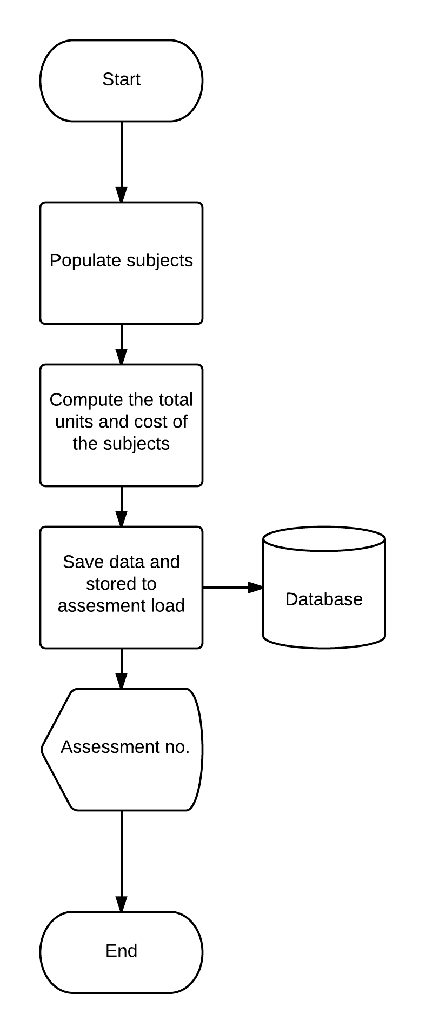

**Diagram no. 8**

**Enrollment Confirmation flowchart**

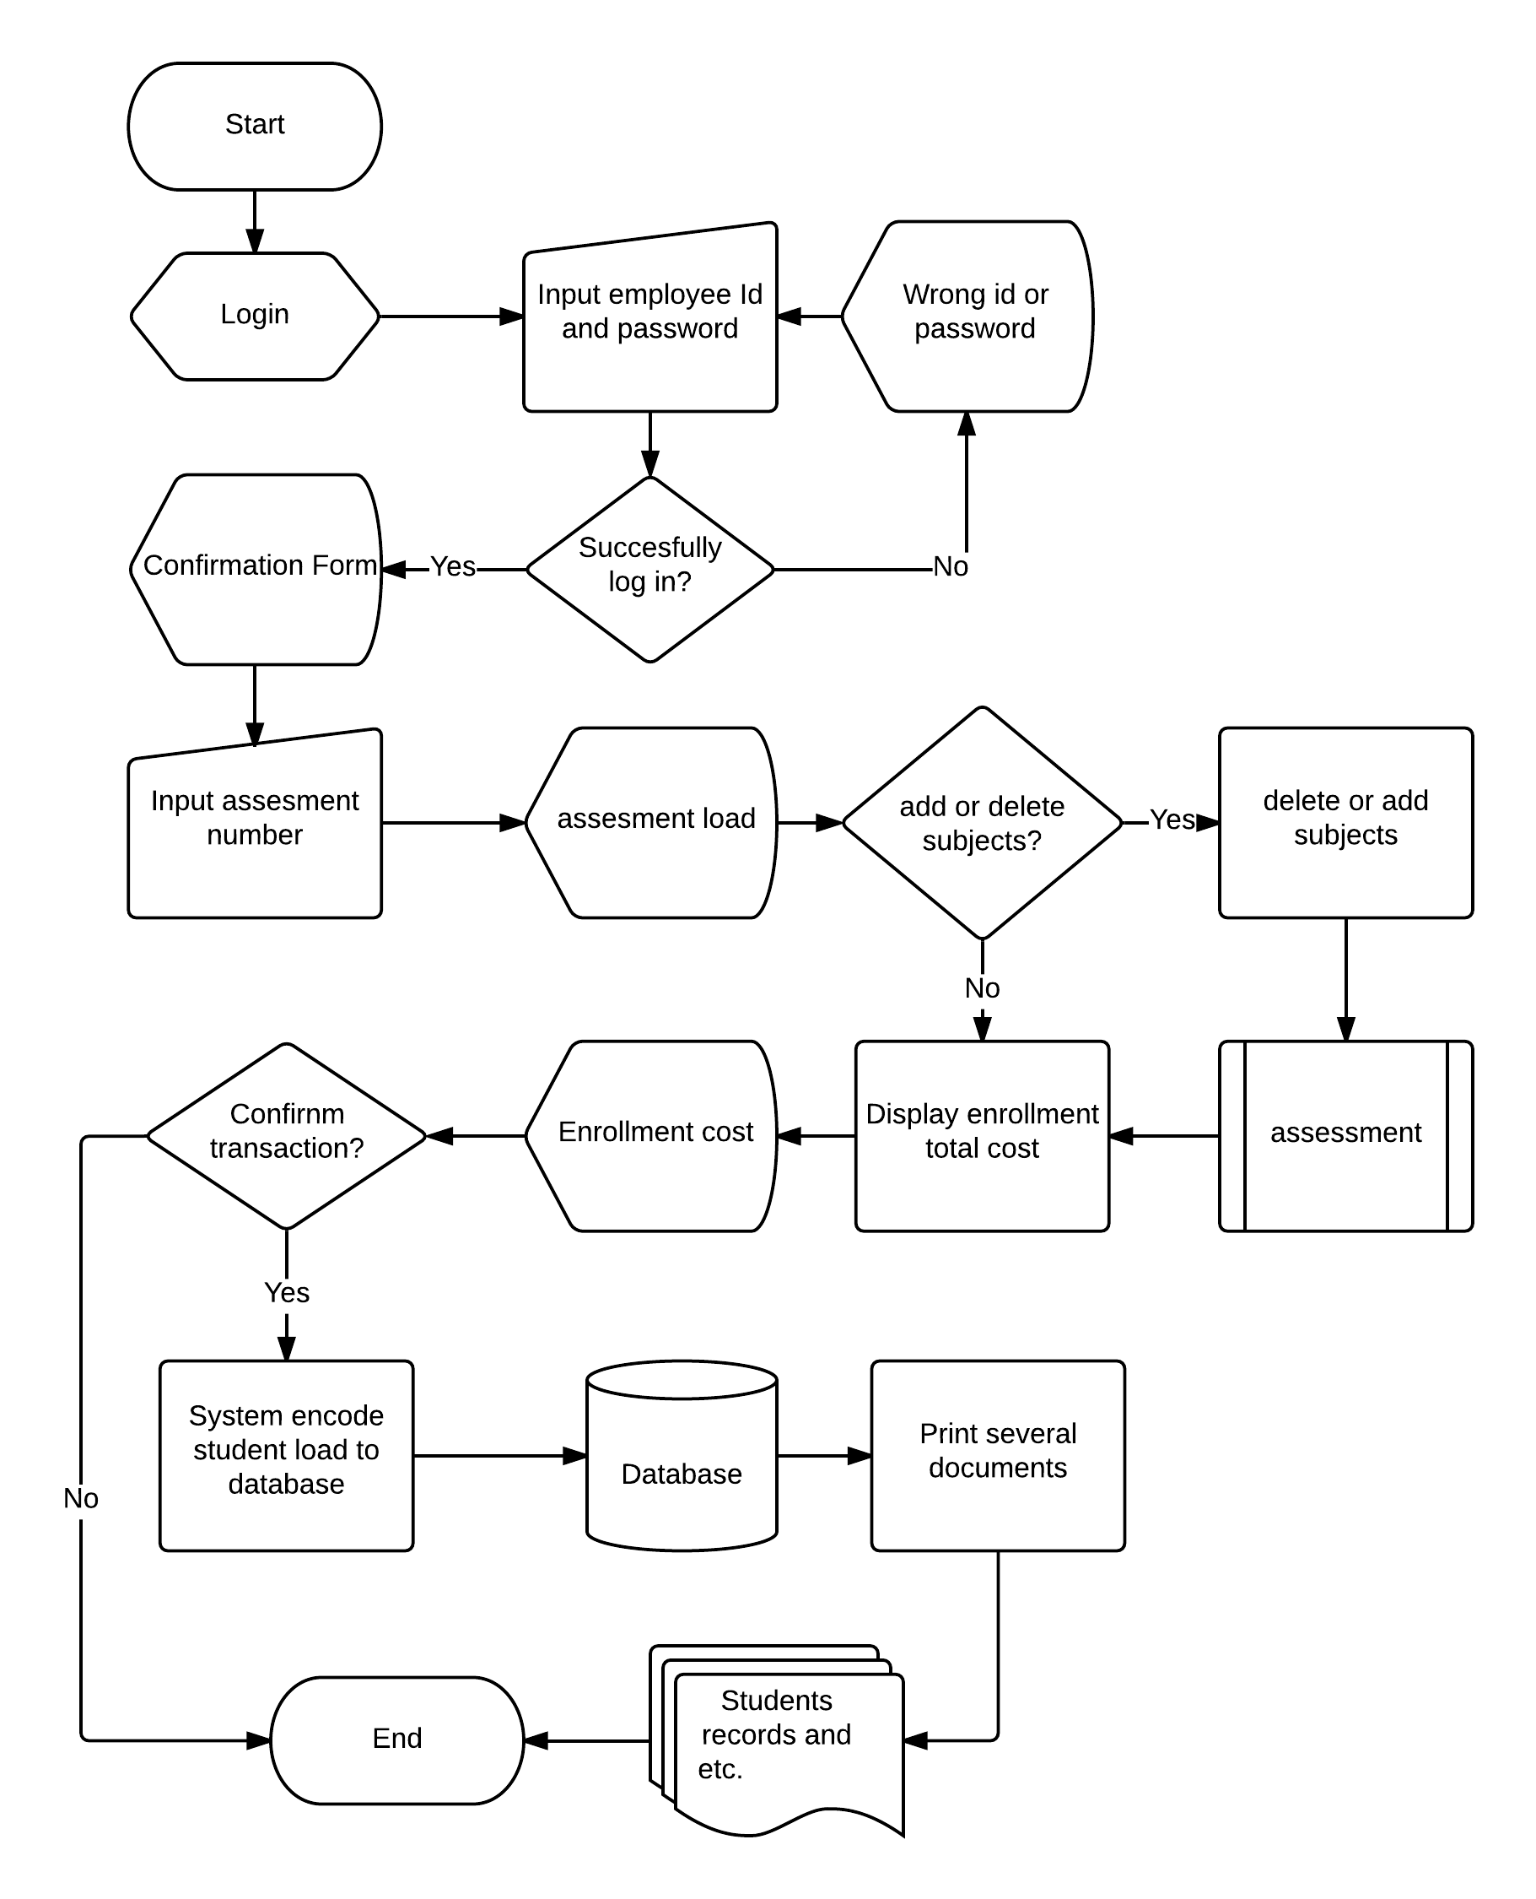

**Diagram no. 9**

**Entity Relationship Diagram**

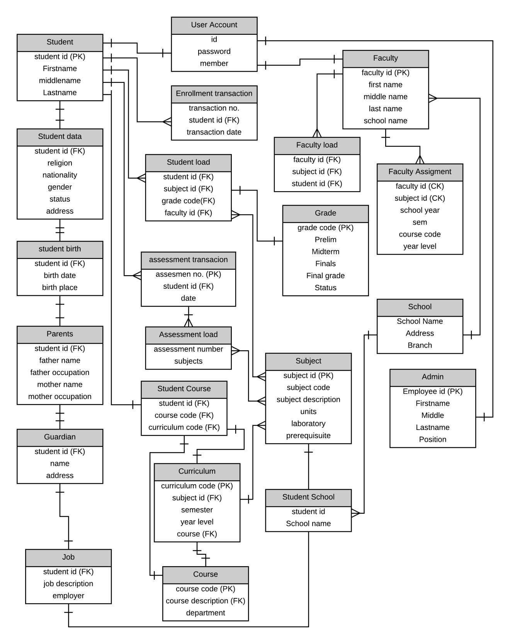

**Diagram no. 10**

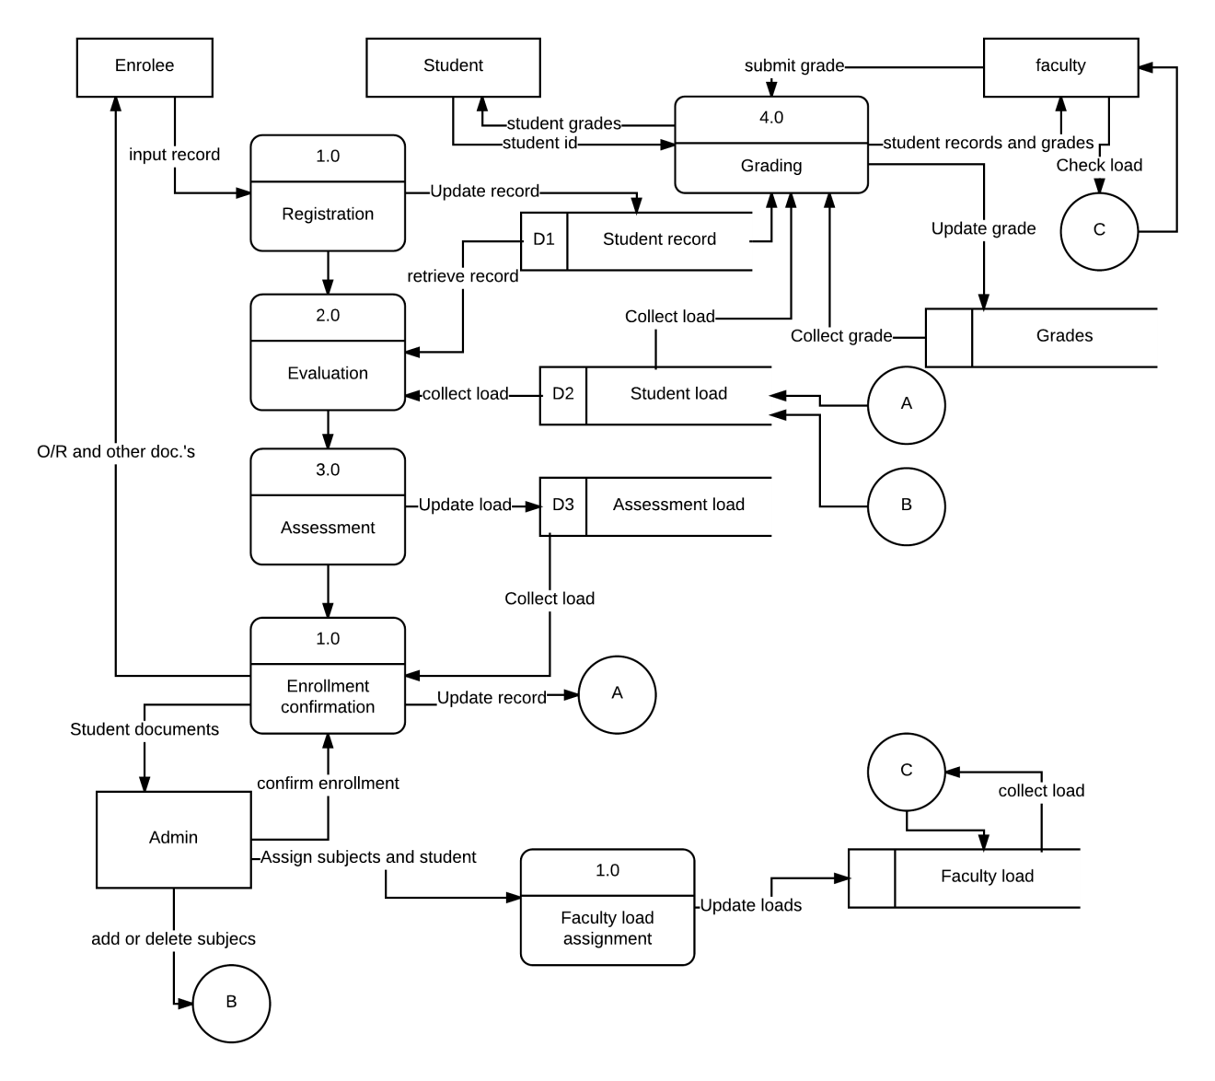**Data flow diagram**

**Diagram no. 11**